Audit log Viewer Process
Screen 1: Dashboard
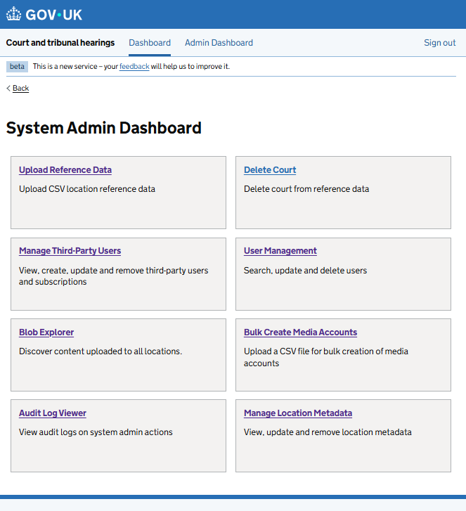

Screen 2: View audit log screen
User screen when Audit Log viewer tab is clicked
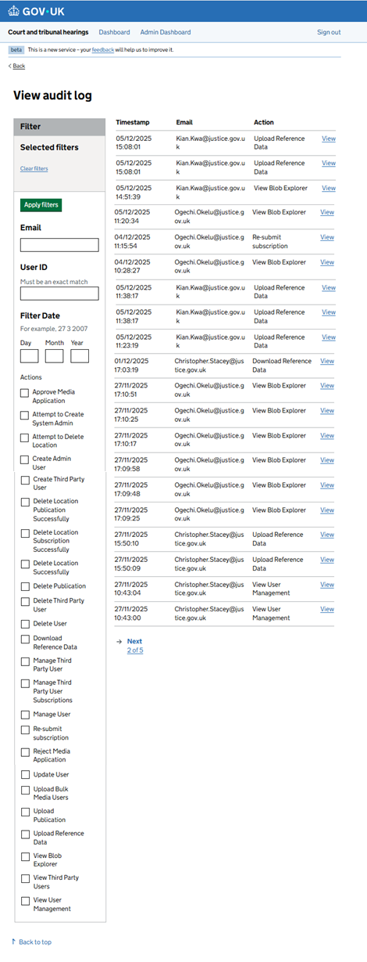
Screen 3: View audit log for [date – dd/mm/yyyy] [time stamp - hr:min:sec]
User screen when user clicks the ‘view’ link beside each audit log entry
